Answers
to Problems
and True/False

CHAPTER 1

6) a) Management science can provide a quantitative methodology for deciding the job-machine pairings so that total job processing time is minimized.
b) How long it takes to process each job on each machine, and any job-machine pairings that are
unacceptable.
c) Decision variables: one for each job-machine pairing, taking on a value of 1 if the pairing is
used and 0 otherwise.
Objective function: minimize total job processing time.
Constraints: each job is assigned to exactly one machine, and each machine be assigned no
more than one job.
d) Stochastic: job processing times vary due to varying machine set-up times, variable operator
performance, and more.
e) Assume that processing times are deterministic (known/fixed).

7) a) The company because of its size and the newness of its product should probably select the simplified model because of the reduced costs and the time period for attaining results. This first pass at the problem most likely will give a "ballpark" figure. The model can then be refined as more experience with production and demand is attained.
b) Because of the large volume and the national distribution, perhaps the more complete study
should be done in this case. Additionally, since the firm is a conglomerate, a more complete
justification of its policy to the stockholders may be required.

8) a) MAX 10s1 + 10s2 + 25s3 b) MAX 1.4x1 + 1.2x2 +1.25x3
S.T. 25s1 < 5,000 S.T. x1 < 5,000
50s2 < 5,000 x2 < 5,000
100s3 < 5,000 x3 < 5,000
25s1 > 1,000 x1 > 1,000
50s2 > 1,000 x2 > 1,000
100s3 > 1,000 x3 > 1,000
25s1+ 50s2 + 100s3 < 10,000 x1 + x2 + x3 < 10,000
s1, s2, s3 > 0 x1, x2, x3 > 0

c) Both give the same result.

9) a) N = L/25; C = 8CgN; C = .32CgL

b) TC = Cn + .32CgL; if L = 50, TC = $260; if L = 65, N = 2.6 guards,
so it must be decided whether to use 2 or 3 guards during the day.

10) a) X1 = number of seats CPI manufactures in quarter 1
X2 = number of seats subcontracted in quarter 1
X3 = number of seats held in inventory from quarter 1 to quarter 2
X4 = number of seats CPI manufactures in quarter 2
X5 = number of seats subcontracted in quarter 2
b) Minimize 10.25X1 + 12.50X2 + 1.50X3 + 10.25X4 + 13.75X5

CHAPTER 1 continued

11) a) X1 < 3800 (1)
X4 < 3800 (2)
X1 + X2 - X3 = 3700 (3)
X3 < 300 (4)
X3 + X4 + X5 = 4200 (5)
b) The real problem is stochastic
c) Three decision variables must be introduced:
X6 = number of seats held in inventory from quarter 2 to quarter 3
X7 = number of seats CPI manufactures in quarter 3
X8 = number of seats subcontracted in quarter 3
Addition to objective function: +1.50X6 + 10.25X7 + 13.75X8
Adjustment to constraint (5) above: X3 + X4 + X5 - X6 = 4200
Three additional constraints:
X6 < 300
X7 < 3800
X6 + X7 + X8 = 3rd quarter demand

12) a) 50s + 30c < 800
s > 5
c > 5
b) (1) Max s + c; (2) Max .03s + .05c; (3) Max 6s + 5c

- a) Variable costs: Assembly labor = $8, Packaging labor = $1,
Packaging material = $11, Components = $630
Fixed costs: Lease, utilities, etc. = $5,000
Cost function: c(x) = 650x + 5,000
b) r(x) = 700x
c) 100
d) $650
e) $20,000

14) False 15) True 16) True 17) True 18) False
19) True 20) False 21) False 22) False 23) False
24) False 25) False 26) False 27) True 28) False

CHAPTER 2

7) a) Let Ej = (# poor, # average, # excellent).
E1 = (4,0,0), E2 = (3,1,0), E3 = (3,0,1), E4 = (2,2,0), E5 = (2,1,1), E6 = (2,0,2),
E7 = (1,3,0), E8 = (1,2,1), E9 = (1,1,2), E10 = (1,0,3), E11 = (0,4,0), E12 = (0,3,1),
E13 = (0,2,2), E14 = (0,1,3), E15 = (0,0,4).
b) {E7,E8}
c) {E9}
d) yes
e) no
f) yes

CHAPTER 2 continued

8) a) .357 9) a) .15 10) a) .162
b) .583 b) .167 b) .37
c) .56 c) .408
d) no

11) a) lower .095; same .469; higher .437
b) .604
c) .384

12) a) 6 13) a) .25 14) a) .4225 15) .304
b) {(G,S,B), (G,B,S)} b) .49 b) .325
c) {(G,S,B)} c) .12 c) .06
d) {(G,B,S)} d) .1925

16) a) (1) .0121; (2) .7921 (3) .1958
b) .15
c) .571
d) No
e) P(Married Prefers) = P(Husband Prefers)P(husband) + P(Wife Prefers)P(Wife) = .145; more.

17) a) .234
b) .829
c) .133
d) yes
e) .987

18) True 19) False 20) False 21) True 22) False
23) False 24) False 25) True 26) True 27) False
28) False 29) False 30) True 31) False 32) True

CHAPTER 3

9) a) (1) P(3) = 1/12, P(4) = 1/12, P(6) = 1/12, P(10) = 1/6, P(16) = 1/4, P(20) = 1/3, all other P(x) = 0.
(2) P(0) = 1/12, P(1) =1/6, P(2) = 1/6, P(3) = 1/6, P(4) = 1/3, all other P(y) = 0
(3) P(0) = 1/12, P(.05) = 1/12, P(.1875) = 1/6, P(.20) = 1/3, P(.25) = 1/6, P(.3) = 1/12, P(.333) = 1/12, all other P(z) = 0
b) all distributions are for discrete random variables
c) (1) the third; (2) the first; (3) the second.
d) 1/2 e) 5/12 f) 13.417 g) 2.583 h) 17.15% i) No

10) a) Relief m = 15, s2 = 150; Comfort m = 15.25, s2 = 6.19
b) Relief
c) Comfort

CHAPTER 3 continued

11) a) .3277 12) a) 40 mph
b) .2048 b) .9332
c) 300 minutes

13) a) 1/2 14) M- .6247 15) a) $30
b) 1/2 T- .3218 b) $45.50
c) 1 W- .1587 c) Yes, new daily profit = $71
d) 0 R- .3721
e) (1) 0 (2) 1/2 F- .6247
f) (1) 1/2 (2) 1 S- .2620
g) 8:10

16) a) μ = 4, σ² = 2.4 17) a) .0120 18) a) f(x) = 1.25 for 31.8 < x < 32.6,
b) .3822 b) .0183 = 0 otherwise
c) 6 b) 0, .375, 0
d) .2335 c) no

19) a) 0, .5, .5, .1587 20) a) Store 1
b) $2 b) Store 1 - .1587, Store 2 - .2266
c) No - Store has larger standard deviation

21) a) .0183, .0733, .1465, .7619
b) .0107
c) .8647

22) False 23) True 24) True 25) False 26) False
27) True 28) False 29) False 30) False 31) True
32) True 33) True 34) False 35) False 36) True

CHAPTER 4

6) a) Stock C -- it dominates Stock B
b) (1) Stock A; (2) Stock C; (3) Stock D
c) Stock D

7) a) Rail Freight
Bid $470,000 Doesn't Bid

Transrail Bid $500,000 0 $100,000
Bid $460,00 $60,000 $ 60,000
b) Bid $460,000
c) Bid $500,000
d) $15,000

CHAPTER 4 continued

8) a) Sales (in 1,000,000's)
100 50 1

Introduce $1,000,000 $200,000 -$2,000,000
Do Not Introduce -$400,000 -$400,000 -$400,000

b) Sales (in 1,000,000's)
100 50 1

Introduce $0 $0 $1,600,000
Do Not Introduce $1,400,000 $600,000 $0

c) (1) do not introduce; (2) introduce; (3) do not introduce d) Yes e) No

9) a) Introduce root beer; p < .483 c) Stanton: EVSI = $13,200 ($11,862)
b) EVPI = $112,000 Efficiency = .118 (.106)
NOTE: The answers to (c)-(e) are New World: EVSI = $6,400 ($6,424)
very sensitive to roundoff error. Efficiency = .057 (.057)
Figures in parentheses are for d) hire Stanton (Stanton)
two decimal places only. e) hire New World (Stanton)

10) a) Number of Subscribers
10,000 20,000 30,000 40,000 50,000 60,000
Plan
I -550 -400 -250 -100 50 200
II -520 -340 -160 20 200 380
III -500 -300 -100 100 300 500
IV -460 -220 20 260 500 740
(table in $1000’s)

b) (1) Plan IV; (2) Plan IV; (3) Plan IV c) Plan II -- Expected Value = $11,000

11) a) Number of Clients Purchasing a Computer
0 1 2 3 4

Number of 1 -40 50 30 10 -10
Computers 2 -70 20 110 90 70
Manufactured 3 -80 10 100 190 170
4 -70 20 110 200 290
(Payoffs are in $1,000's)
b) Build 4 computers
c) Nothing

12) a) Yes, Dollar should sell store b) EVPI = $8,000 c) No; survey cost exceeds EVPI

CHAPTER 4 continued

13) a) Number of Copies (in 1,000's per month)
12.6 14.4 16.2 18.0 19.8 21.6
Plan
I 341.6 370.4 399.2 428.0 456.8 485.6
II 351.2 372.8 394.4 416.0 437.6 459.2
III 317.2 356.8 396.4 436.0 475.6 515.2
IV 363.0 372.0 381.0 390.0 399.0 408.0

b) (1) Plan III; (2) Plan IV
c) Plan IV

14) Demand For Ovens
0 1 2 3

0 0 -25 -50 -75
Ovens 1 -70 80 55 30
Ordered 2 -140 10 160 135
3 -210 -60 90 240

a) Order one oven -- EV = $25.00
b) EVPI = $63
c) Favorable: order 2; Unfavorable: order 0; No opinion: order 1
d) EVSI = $9.10

15) False 16) True 17) False 18) False 19) False
20) False 21) True 22) False 23) True 24) False
25) False 26) True 27) True 28) False 29) False

CHAPTER 6

6) a) 4 period weighted moving average; MSE = 408
b) exponential smoothing -- $298.48
weighted moving average -- $294.27

7) a) σ = .6 is better MSE (9.12); σ = .2 has MSE = 10.82
b) For σ = .6, F9 = 22.86; for σ = .2, F9 = 21.72

8) Year 6: Quarter 1 -- 56; Quarter 2 -- 48; Quarter 3 -- 79; Quarter 4 -- 40

- a) The 3 week moving average gives the better forecast (MSE = 16,337)
(compared to a MSE = 17,911 for the 4 week moving average)
b) 3 week moving average forecast for week 11 = 1,200
4 week moving average forecast for week 11 = 1,158

CHAPTER 6 continued

10) a) Yes; y = 11.93 + 1.0046x
b) Week 17 -- 29.0; Week 18 -- 30.0; Week 19 -- 31.0; Week 20 -- 32.0

11) b) 141.44, 144.18, 119.44, 157.72, 111.93

12) a) Ft = 34.80 - 1.329t
b) 26 months
c) After 27 months sales will be approximately -1 cars; this is clearly impossible;
the assumption of a continued linear decline must be in error.

13) 42.15, 70.14, 52.17; 43.46, 72.30, 53.76

14) a) y = 80.8757 + 5.3605(x)
b) y = 80.8757 + 5.3605(33.5) = 260.45245 hours for a 3350 sq. ft. house.

15) True 16) True 17) False 18) True 19) False
20) True 21) True 22) False 23) True 24) True
25) False 26) True 27) False 28) False 29) False

CHAPTER 7

9) X1 = 0, X2 = 4; Z = 48

- a) X1 = 4, X2 = 3/2; Z = 19 b) All points on line 2X1 + X2 = 6 between (3,0) and (24/13,30/13).

11) a-b) extreme points: (0,4), (1,2), (3,1) -- feasible region is unbounded.
c) (1) optimal solution X1 = 3, X2 = 1, Z = 1
(2) alternate optimal solutions on X1 - 2X2 = 1 above (3,1)
(3) unbounded linear program

12) a) X1 = 3, X2 = 4; Z = 29 b) No change. If only a single point is feasible,
objective function’s slope is inconsequential.

13) a) X1 = 10, X2 = 15, Z = 230
b) Any point satisfying all the other constraints will also satisfy constraint 1
c) X1 = 20, X2 = 15, Z = 310

14) a) MAX 60X1 + 43X2
S.T. X1 + 3X2 - S1 = 9
6X1 − 2X2 = 12
X1 + 2X2 + S3 = 10
X1, X2, S1, S3 > 0
b) line segment of 6X1 – 2X2 = 12 between (22/7,24/7) and (27/10,21/10).
c) Extreme points: (22/7,24/7) and (27/10,21/10). First one is optimal giving Z = 336.

15) a) (35,0) Z = $630,000 b) (5,12) Z = $630,000 c) (10,10) Z = $630,000

CHAPTER 7 continued

16) a) 100 dozen childs, 66 2/3 doz. adults, profit = $12,333.33; both slack variables = 0.
b) this point is an interior point in the original formulation

17) True 18) True 19) True 20) False 21) False
22) False 23) False 24) False 25) False 26) True
27) True 28) True 29) False 30) True 31) False

CHAPTER 8

7) a) 1500 shares of airlines stock, 800 shares of insurance stock; the expected return is $5400
b) Between $0 and $2.40

8) a) 6 product 1, 4 product 2, Profit = $540
b) Between $50 and $75; at $70 the profit is $580
- No – total % change is 83 1/3% < 100%
d) Dual prices are the shadow prices for the resources; since there was unused copper (because
S2 = 2), extra copper is worth $0
e) $30
- $10; this is the amount extra man-hours are worth
g) The shadow price is the "premium" for aluminum -- would be willing to pay up to $10 + $30 = $40 for extra aluminum

9) a) Standard -- 33 1/3, Slim-Line -- 266 2/3, Z = $1100
b) $5.60
c) Standard -- 86 2/3, Slim-Line -- 213 1/3, Z = $1180

10) a) No b) No c) Yes -- Sum of % changes > 100% d) $10 -- Value of extra man-hours
e) $1 -- this is the "premium" value for the boxes; hence extra boxes are worth $1.25
f) They will stay the same -- Sum of % changes < 100%

11) a) 200 shares of James, 20 shares of QM, 40 shares of Delic. Total gain = $3200
b) Each dollar increase in the allowed minimum investment in QM will result in a $.05 decrease in the total $ gain.
c) Constraint #1 dual price (.25) X 1000 = $250
d) No. It would be James Ind. (only stock with + dual price)
e) Constraint #2 dual price (.15) X 1000 = $150
- Allowed max. investment could be raised to $8000
g) No, cumulative change does not exceed 100%

12) a) X1 = 2, X2 = 4, Z = 32 b) 5 < C1 < 10; 3 < C2 < 6 c) X1 = 0, X2 = 6
d) 1; improvement in the objective function for an extra unit of iron
e) Zinc’s shadow price = 0 as long as this line does not determine the optimal point (its RHS < 2).

13) a) 120 containers of jade figurines, 60 containers of linen placemats; Profit = $13,200
b) Between $30 and $120 c) (1) $6.67; (2) $16.67; (3) $0

CHAPTER 8 continued

14) a) 105 minivans, 75 trailers; $673,500 profit
b) $2812.50 < minivan profit < no upper limit, no lower limit < trailer profit < $5120.00
c) Dual price for yardman hours is $1600. Thus, an increase of $1600 in monthly profit can be gained for each hour increase in the monthly availability of yardmen!

15) a) 10,000 mi. on Harley; 35,000 mi. on Hauler b) $15.00 c) 7.5 cents

16) True 17) True 18) True 19) True 20) False
21) False 22) True 23) True 24) True 25) True
26) True 27) True 28) True 29) False 30) True

CHAPTER 9

11) a) MAX 2X1 + X2 + .75X3 + .5X4 + .75X5 + 1.5X6
S.T. 20X1 + 16X2 + 13X3 + 9X4 + 12X5 + 17X6 < 550
X1 + X2 + X3 + X4 + X5 + X6 > 40
X1 + X2 + X3 - 2X4 - 2X5 - 2X6 > 0
X1 + X2 + X5 + X6 > 20
Xj > 0 j = 1,...,6

Solution: X₁ = 5.833, X₂ = 0.833, X₃ = 20, X₄ = 0, X₅ = 13.333, X₆ = 0; Total = 37.5 tons

b) The variables must be integers.

12) Pi = the number of producers in month i (where i = 1,2,3)
Ti = the number of trainers in month i (where i = 1,2)
Ai = the number of apprentices in month i (where i = 2,3)
Ri = the number of recruits in month i (where i = 1,2)

MIN 3000P1 + 3300T1 + 2200R1 + 3000P2 + 3300T2 + 2600A2+2200R2 + 3000P3 + 2600A3
s.t. .6P1 + .3T1 +.05R1 > 20
.6P1 + .3T1 + .05R1 + .6P2 + .3T2 + .4A2 + .05R2 > 44
.6P1+.3T1+.05R1+.6P2+.3T2+.4A2+.05R2+.6P3+.4A3 > 74
P1 - P2 + T1 - T2 = 0
P2 - P3 + T2 + A2 = 0
A2 - R1 = 0
A3 - R2 = 0
2T1 - R1 > 0
2T2 - R2 > 0
P1 + T1 = 100
P3 + A3 > 140
Pj, Tj, Aj, Rj > 0 for all j

Solution: P₁ = 100, T₁ = 0, R₁ = 0, P₂ = 80, T₂ = 20, A₂ = 0, R₂ = 40, P₃ = 100, A₃ = 40
Total cost = $1,098,000.

CHAPTER 9 continued

13) Xj = the number of instrument j produced; where j = 1(deluxe trumpet); 2(prof. trumpet);
3(deluxe cornet); 4(prof. cornet)

MAX 80X1 + 160X2 + 60X3 + 120X4
s.t. 2X1 + 1.5X2 + 1.5X3 + X4 < 2000
X1 + 1.5X2 + X3 + 1.5X4 < 1800
X1 > 500
X3 > 300
X2 < 150
X4 < 100
X1 + X2 - 2X3 - 2X4 = 0
Xj > 0 j = 1,...,4

Solution: X₁ = 620, X₂ = 150, X₃ = 300, X₄ = 85; Total profit = $101,800.

14) a) MAX 5X1+ 12X2+ 25X3+ 4X4+ 10X5+ 18X6+ 9X7+ 16X8
S.T. 1.8X1+2.2X2+ 3X3+.74X4+1.6X5+2.2X6+ X7+1.5X8 < 300
1.8X1+2.2X2+ 3X3 > 75
1.8X1+2.2X2+ 3X3 < 120
.74X4+1.6X5+2.2X6 > 75
.74X4+1.6X5+2.2X6 < 120
X7+1.5X8 > 30
X7+1.5X8 < 75
.75X1 -.25X2 -.25X3+.75X4 -.25X5 -.25X6-.25X7 -.25X8 > 0
Xj > 0 j = 1,...,8
b) X1 = 0, X2 = 0, X3 = 40, X4 = 41.28, X5 = 0, X6 = 33.84, X7 = 0, X8 = 50, Z = 2,574.28
c) The variables must be integers.

15) X11 = pounds of chocolate used in Chompers
X21 = pounds of chocolate used in Smerks
X31 = pounds of chocolate used in Delicious Chocolate
X12 = pounds of caramel used in Chompers
X22 = pounds of caramel used in Smerks
X23 = pounds of peanuts used in Smerks
Y1 = number of one ounce Chompers bars produced daily
Y2 = number of one ounce Smerks bars produced daily
Y3 = number of one ounce Delicious Choc. bars produced daily
Y4 = number of one pound Delicious Choc. bags produced daily

CHAPTER 9 continued

15) continued
MAX .128Y1+.148Y2+.138Y3+2.261Y4-1.60X11-1.60X21-1.60X31-.95X12-.95X22 -1.40X23
s.t. (1/16)Y3 + Y4 = X31
(1/16)Y1 = X11 + X12
(1/16)Y2 = X21 + X22 + X23
X12 > .18(X11 + X12)
X12 < .28(X11 + X12)
X22 = X23
X21 > .20(X21 + X22 + X23)
X21 < .40(X21 + X22 + X23)
Y1 + Y2 + Y3 < 20,000
Y4 < 1,000
Y1 > 3,000
Y2 > 3,000
Y3 > 3,000
Y1 - Y2 < .10(Y1 + Y2)
Y2 - Y1 < .10(Y1 + Y2)
X11 + X21 + X31 > 1,000
X12 + X22 = 350
X23 < 500
Xij > 0 i = 1,2,3; j =1,2,3
Yj > 0 j = 1,2,3,4

Solution: Y₁ = 7650, Y₂ = 9350, Y₃ = 3000, Y₄ = 1000
X₁₁ = 361.875, X₁₂ = 116.25
X₂₁ = 116.875, X₂₂ = 233.75, X₂₃ = 233.75
X₃₁ = 1187.5; Total daily profit = $1,712.25

16) X1 = number of bulldozers purchased for the year
X2 = number of bulldozers leased for the year
annual cost = (purchasing) + (leasing) - (salvage) - (interest)
= (40,000X1)+(8000X2)-(20,000X1)-0.08(1,000,000 - 40,000X1 - 8,000X2)
= 23,200X1 + 8,640X2 - 80,000. Thus,
MIN 23,200X1 + 8,640X2
s.t. . 4,000X1 + 8,000X2 < 1,000,000
8X1 + 5X2 > 240
X1, X2 > 0
Solution: Buy 0 bulldozers, lease 48; Annual cost = $334,720

17) Xj = $ invested in investment j; where j = 1(Uni Eq.), 2(Col. Must.), 3(1st Gen REIT), 4(Met. Elec.), 5(Uni Debt), 6(Lem. Trans.), 7(Fair. Apt.), 8(T-Bill), 9(Money Market), 10(All Saver's)
MAX .15X1 + .17X2 + .175X3 + .118X4 + .122X5 + .12X6 + .22X7 + .096X8 + .105X9 + .126X10
S.T. X1 + X2 + X3 + X4 + X5 + X6 + X7 + X8 + X9 + X10 = 400,000
100X1 + 100X2 + 100X3 + 95X4 + 92X5 + 79X6 + 80X8 + 100X9 >
65(X1 + X2 + X3 + X4 + X5 + X6 + X7 + X8 + X9 + X10)
60X1 + 70X2 + 75X3 + 20X4 + 30X5 + 22X6 + 50X7 + 10X9 <
55(X1 + X2 + X3 + X4 + X5 + X6 + X7 + X8 + X9 + X10)

CHAPTER 9 continued

17) continued
X1 + X5 < 60,000
X1 + X2 + X3 < 160,000
X4 + X5 + X6 < 160,000
X3 + X7 < 160,000
X1 < 80,000
X2 < 80,000
X3 < 80,000
X4 < 80,000
X5 < 80,000
X6 < 80,000
X7 < 80,000
X8 < 80,000
X9 > 1,000
X10 < 15,000
X4 + X5 + X6 > 90,000
X8 > 10,000
Xj > 0 j = 1,...,10

Solution: X₁ = 0; X₂ = 80,000; X₃ = 80,000; X₄ = 0; X₅ = 60,000; X₆ = 74,000;
X₇ = 80,000; X₈ = 10,000; X₉ = 1,000; X₁₀ = 15,000; Total return = $64,355.

18) X1 = amount invested in new soda advertising
X2 = amount invested in traditional soda advertising
MAX X1 + 4X2 <==== 02(50X1) + .04(100X2)
S.T. X1 + X2 < 10,000,000
X1 > 5,000,000
X2 > 2,000,000
50X1 + 100X2 > 750,000,000
X1, X2 > 0

Answer: spend $5,000,000 on new soda ad, spend $5,000,000 on traditional ad, profit = $25 mil

19) X1-X3 = number of students from NE to McHale,McCallum,McBride
X4-X6 = number of students from SE to McHale,McCallum,McBride
X7-X9 = number of students from SW to McHale,McCallum,McBride
X10-X12 = number of students from NW to McHale,McCallum,McBride
X13-X15 = number of students from Central to McHale,McCallum,McBride

MIN 1.5X1 + 2.5X2 + .5X3 + 4X4 + 1.5X5 + 3X6 + 2.5X7 + 3X8
+ 3.5X9 + .5X10 + 4X11 + 1.5X12 + 1X13 + 2X14 + 1X15
S.T. X1 + X2 + X3 = 700
X4 + X5 + X6 = 1100
X7 + X8 + X9 = 900
X10 + X11 + X12 = 600
X13 + X14 + X15 = 800
X1 + X4 + X10 + X13 < 1500
X2 + X5 + X11 + X14 < 1800
X3 + X6 + X12 + X15 < 1100
Xj > 0 j = 1,2,...,15

CHAPTER 9 continued

19) continued
Solution: 700 students from NE to McBride, 1100 from SE to McCallum
500 from SW to McHale, 400 from SW to McCallum, 600 from NW to McHale,
400 from Central to McHale, and 400 from Central to McBride.

20) E = .968; Alabama store appears moderately inefficient

21) X1-X4 = number of full-time clerks starting at 8,9,10,11am
X5-X11 = number of part-time clerks starting at 8,9,10,11am and 12,1,2pm

MIN 63X1+63X2+63X3+63X4+26X5+26X6+26X7+26X8+26X9+26X10+26X11
S.T. X1 > 1
X4 > 1
X1 + X2 + X3 + X4 > 4
X1 + X5 > 5
X1 + X2 + X5 + X6 > 4
X1 + X2 + X3 + X5 + X6 + X7 > 6
X2 + X3 + X4 + X5 + X6 + X7 + X8 > 8
X1 + X3 + X4 + X6 + X7 + X8 + X9 > 10
X1 + X2 + X4 + X7 + X8 + X9 + X10 > 9
X1 + X2 + X3 + X8 + X9 + X10 + X11 > 7
X2 + X3 + X4 + X9 + X10 + X11 > 4
X3 + X4 + X10 + X11 > 7
X4 + X11 > 5
Xj > 0 j = 1,2,...,11

Solution: X₁ = 1, X₂ = 0, X₃ = 0, X₄ = 3, X₅ = 4,
X₆ = 3, X₇ = 0, X₈ = 3, X₉ = 0, X₁₀ = 2, X₁₁ = 2, Total labor cost = $616.

22) False 23) False 24) True 25) False 26) True
27) True 28)True 29) True 30) False 31) False
32) False 33) False 34) False 35) False 36) False

CHAPTER 10

8. a)
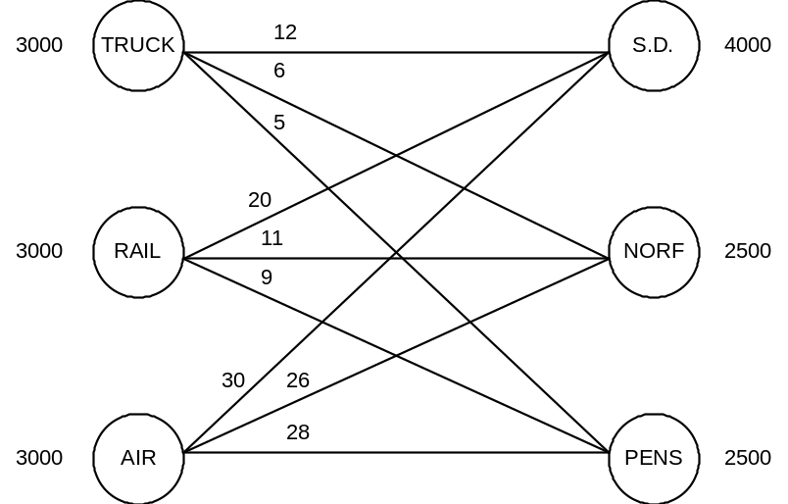

b) Let: P_{TS} , P_{TN} , P_{TP} = lbs. of material shipped by truck to San Diego, Norfolk, Pensacola
P_{RS} , P_{RN} , P_{RP} = lbs. of material shipped by railroad to San Diego, Norfolk, Pensacola
P_{AS} , P_{AN} , P_{AP} = lbs. of material shipped by airline to San Diego, Norfolk, Pensacola

Min 12P_{TS} + 6P_{TN} + 5P_{TP} + 20P_{RS} + 11P_{RN} + 9P_{RP} + 30P_{AS} + 26P_{AN} + 28P_{AP}
s.t. P_{TS} + P_{TN} + P_{TP} < 3000
P_{RS} + P_{RN} + P_{RP} < 3000
P_{AS} + P_{AN} + P_{AP} < 3000
P_{TS} + P_{RS} + P_{AS} = 4000
P_{TN} + P_{RN} + P_{AN} = 2500
P_{TP} + P_{RP} + P_{AP} = 2500
P_{TS} , P_{TN} , P_{TP} , P_{RS} , P_{RN} , P_{RP} , P_{AS} , P_{AN} , P_{AP} > 0

c) Truck – S.D. 1000; Truck – Norf. 2000; Rail – Norf. 500; Rail – Pens. 2500; Air – S.D. 3000

9) a) Let: A_{N1} , A_{N2} , A_{N3} , A_{N4} = number of newspaper ads by MR1, MR2, MR3, MR4
A_{T1} , A_{T2} , A_{T3} , A_{T4} = number of television ads by MR1, MR2, MR3, MR4
A_{R1} , A_{R2} , A_{R3} , A_{R4} = number of radio ads by MR1, MR2, MR3, MR4

Min 16A_{N1} + 10A_{N2} + 12A_{N3} + 12A_{N4} + 26A_{T1} + 20A_{T2} + 30A_{T3} + 21A_{T4} + 22A_{R1} + 15A_{R2}
+ 23A_{R3} + 14A_{R4}

s.t. A_{N1} + A_{T1} + A_{R1} < 15
A_{N2} + A_{T2} + A_{R2} < 25
A_{N3} + A_{T3} + A_{R3} < 10
A_{N4} + A_{T4} + A_{R4} < 20
A_{N1} + A_{N2} + A_{N3} + A_{N4} = 30
A_{T1} + A_{T2} + A_{T3} + A_{T4} = 15
A_{R1} + A_{R2} + A_{R3} + A_{R4} = 25 and all A’s > 0

CHAPTER 10 continued

9) b) Newspaper - MR1 15; Newspaper - MR2 5; Newspaper - MR3 10; TV - MR2 15;
Radio - MR2 5; Radio - MR4 20; Total Cost = $1,065,000
c) Newspaper - MR2 20; Newspaper - MR3 10; TV - MR1 15; Radio - MR2 5;
Radio - MR4 20; Total cost = $1,065,000
d) Many answers. One with TV-MR1 = 5 is: Newspaper - MR1 10;
Newspaper - MR2 10; Newspaper - MR3 10; TV - MR1 5; TV - MR2 10;
Radio - MR2 5; Radio - MR4 20; Total cost = $1,065,000

10) Ace: 25 Sanitation and 5 Police; Band: 25 Parks and 15 Administration;
QM: 20 Police and 10 Administration; Cost $1,035,000

11) LA-Denver 25; LA-NY 10; CHI-NY 30; NY-ATL 35; Profit $2,165,000

12) Abbey-Cab3, Babbs-Cab4, Carla-Cab2, Diane-Cab5, Ellsa-Cab1; Performance rating total = 35

13) a) (diagram below)
b) Computer Town - P5; Computer World - P4; Universal - P1;
Local Computer - P2 and P3; Total Cost $71,000
c) +M placed in matrix in row 2, column 5; no change in solution
d) +M's placed in assignment matrix row 2 column 4, and in row 2 column 5;
Computer Town - P5; Computer World - P2; Universal - P1;
Local Computer - P3 and P4; Total cost = $77,000

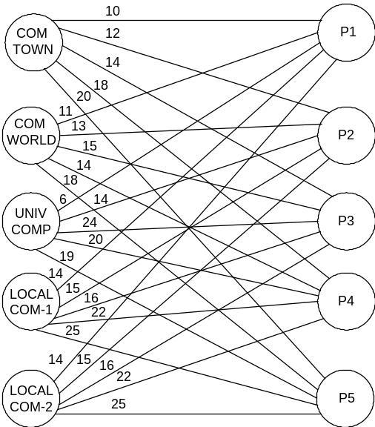

14) Division 1 - Bats; Division 2 - Golf Clubs;
Division 3 - Racquetball Rackets; Division 4 - Tennis Rackets; Total 410

CHAPTER 10 continued

15) a)
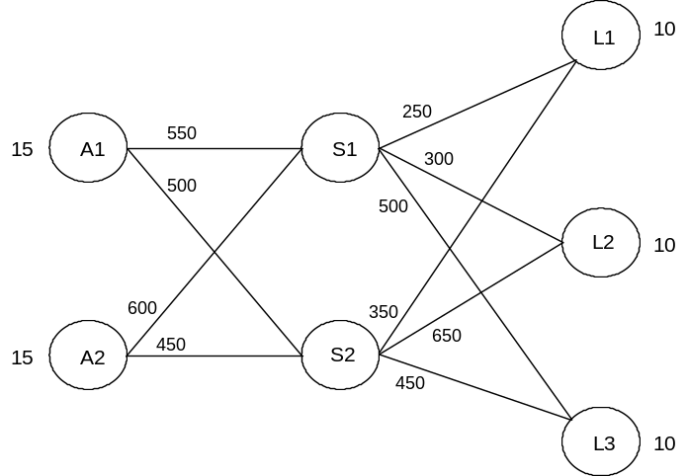

15) b) Denote A1 as node 1, A2 as node 2, S1 as node 3, S2 as node 4,
L1 as node 5, L2 as node 6, and L3 as node 7

MIN 550X13 + 500X14 + 600X23 + 450X24 + 250X35 + 300X36 + 500X37
+ 350X45 + 650X46 + 450X47
S.T. X13 + X14 < 15
X23 + X24 < 15
X13 + X23 - X35 - X36 - X37 = 0
X14 + X24 - X45 - X46 - X47 = 0
X35 + X45 = 10
X36 + X46 = 10
X37 + X47 = 10
Xij > 0 for all i,j

Solution: X₁₃ = 15, X₁₄ = 0, X₂₃ = 0, X₂₄ = 15,
X₃₅ = 5, X₃₆ = 10, X₃₇ = 0, X₄₅ = 5, X₄₆ = 0, X₄₇ = 10, Total cost = $25,500.

16) True 17) True 18) False 19) True 20) True
21) False 22) False 23) False 24) True 25) True
26) True 27) False 28) True 29) False 30) True

CHAPTER 13

6) a)
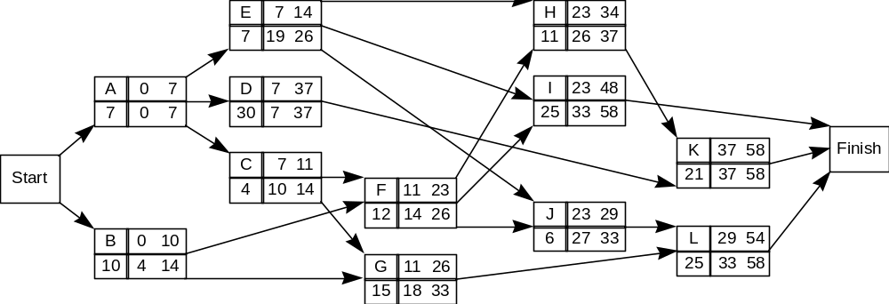

Expected Completion Time = 58; Critical Path = A - D - K
b) Yes
c) Yes
d) Slack on G = 7 hours; Slack on L = 4 hours
e) 4 hours; the slack times are not independent as G and L are on the same path.

7) a) Activity ES EF LS LF Slack
A 0:00 4:00 0:00 4:00 0
B 0:00 3:00 6:00 9:00 6
C 4:00 9:00 17:00 22:00 13
D 4:00 7:00 8:00 11:00 4
E 4:00 9:00 4:00 9:00 0
F 9:00 11:00 9:00 11:00 0
G 9:00 10:00 15:00 16:00 6
H 11:00 13:00 20:00 22:00 9
I 11:00 14:00 20:00 23:00 9
J 11:00 16:00 11:00 16:00 0
K 13:00 14:00 22:00 23:00 9
L 16:00 23:00 16:00 23:00 0

b) A - E - F - J - L; 23 hours
c) There are many; here is one. Note that for Man 2, activity D must precede activity C (D's LS is 8:00 and C's EF is 9:00).
Intern 1 Intern 2
A 0:00 - 4:00 B 0:00 - 3:00
E 4:00 - 9:00 D 4:00 - 7:00
F 9:00 - 11:00 C 7:00 - 12:00
J 11:00 - 16:00 G 12:00 - 13:00
L 16:00 - 23:00 H 13:00 - 15:00
I 15:00 - 18:00
K 18:00 - 19:00

CHAPTER 13 continued

8) a)
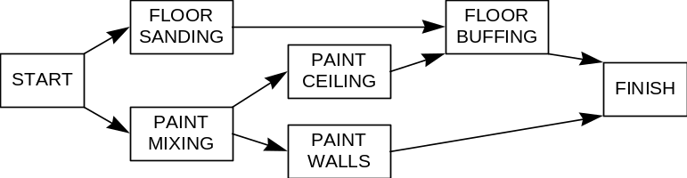
b) 8 hrs.
c) .8264

9) a) Activity ES EF LS LF Slack
A 0 6 2 8 2
B 0 8 0 8 0
C 6 7 8 9 2
D 6 9 9 12 3
E 8 11 9 12 1
F 8 12 9 13 1
G 8 18 8 18 0
H 8 13 10 15 2
I 11 14 12 15 1
J 12 13 14 15 2
K 12 17 13 18 1
L 14 17 15 18 1

b) Critical Path: B - G; Expected completion time = 18 weeks c) Train its own employees

10) a) 16 weeks = Aug. 21 b) About Sept. 22 (20.66 weeks from May 1) c) Do not accept the offer

11) a) Expected Project Completion Time = 32; Standard deviation = 3.16
b) Do not spend the money
c) Activities off the critical path may vary enough so that a new critical path could be formed.

12) a) For this problem label the activities as follows:
A = Feasibility Study D = Advert. Staff Selected G = Prototype Manufactured
B = Building Purchased E = Materials Purchased H = Production Run of 100
C = Project Leader Hired F = Manufacturing Staff Hired I = Advertising Campaign

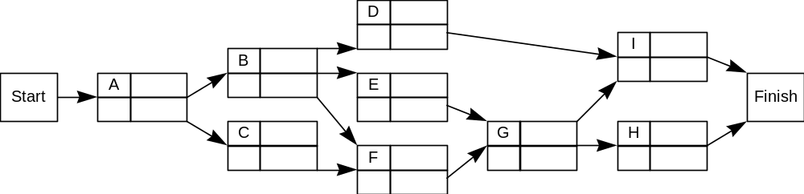

CHAPTER 13 continued

12) b) Define Xi = earliest finish time for activity i Yi = the amount of time activity i is crashed
MIN 20YA + 50YC + 50YD + 70YE + 60YF + 350YH + 75YI (in $000)
S.T. XA > 0 + (6 - YA) XI > XD + (8 - YI)
YA < 1 XB > XA + 4 XI > XG + (8 - YI)
YC < 1 XC > XA + (3 - YC)
YD < 3 XD > XB + (6 - YD) XH < 26
YE < 1 XE > XB + (3 - YE) XI < 26
YF < 3 XF > XB + (10 - YF)
YH < 1 XF > XC + (10 - YF) Xi, Yj > 0 for all i
YI < 4 XG > XE + 2
XG > XF + 2
XH > XG + (6 - YH)

Solution: X_{A} = 5, X_{B} = 9, X_{C} = 9, X_{D} = 18, X_{E} = 16, X_{F} = 16, X_{G} = 18, X_{H} = 24, X_{I} = 26,
Y_{A} = 1, Y_{C} = 0, Y_{D} = 0, Y_{E} = 0, Y_{F} = 3, Y_{H} = 0, Y_{I} = 0, Total crash cost = $200,000.

c) The time reduction for each activity is proportional to the crashing money spent on that activity.
d) Per-week reduction cost is shadow price for XH < 26 or XI < 26.

13) The PERT network for this problem is:
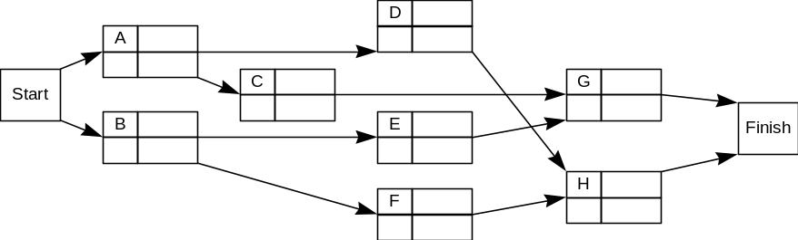

a) Define Xi = earliest finish time for activity i Yi = the amount of time activity i is crashed
MIN 2000YA+2000YC+500YD+500YE+2000YF+5000YG+6000YH
S.T. XA > 0 + (6 - YA) XH > XD + (7 - YH)
YA < 2 XB > 0 + 3 XH > XF + (7 - YH)
YC < 3 XC > XA + (9 - YC)
YD < 2 XD > XA + (4 - YD) XG < 16
YE < 1 XE > XB + (2 - YE) XH < 16
YF < 2 XF > XB + (3 - YF)
YG < 1 XG > XC + (5 - YG) Xi, Yj > 0 for all i
YH < 2 XG > XE + (5 - YG)

Solution: X_{A} = 4, X_{B} = 6, X_{C} = 11, X_{D} = 9, X_{E} = 11, X_{F} = 9, X_{G} = 16, X_{H} = 16,
Y_{A} = 2, Y_{C} = 2, Y_{D} = 0, Y_{E} = 0, Y_{F} = 0, Y_{G} = 0, Y_{H} = 0, Total crash cost = $8,000.

- Same formulation as (a) except: objective function is now MIN XI with constraints XI > XG and
XI > XH and 1250YA+2000YC+500YD+500YE+2000YF+5000YG+6000YH < 50,000

CHAPTER 13 continued

14) [Activity, ES, EF, LS, LF, Slack]
[A, 0, 4, 0, 4, 0]; [B, 4, 7, 4, 7, 0]; [C, 4, 8, 6, 10, 2]; [D, 7, 9, 8, 10, 1]; [E, 7, 12, 7, 12, 0]
[F, 9, 11, 10, 12, 1]; [G, 12, 17, 12, 17, 0]; [H, 9, 15, 11, 17, 2]

15) True 16) True 17) False 18) False 19) True
20) True 21) False 22) False 23) False 24) True
25) True 26) True 27) False 28) True 29) True

CHAPTER 14

9) a) 75 b) Q* = 273.861, order 274 c) $164.32 d) Order every 4 mos. based on forecast

10) a) 1) Buy: Q* = 800; Tot. Annual Var. Cost = $1200; Tot. Annual Cost = $76,200
2) Make: Q* = 5345; Tot. Annual Var. Cost = $5,986.65; Tot. Annual Cost = $75,986.65.
b) Harrison should manufacture displays; total cost is cheaper.

11) a) Q* = 109,544.5 or 109,545 b) 13.33 c) 115 days = 365 - (9.13)(13.33 + 14)

12) Order 2000 every week

13) a) (1) Q* = 16 (2) 20 or when inventory reaches 4 and one order is pending (3) $47,840
b) No; Yearly net profit under this policy is only $45,774

14) Q* = 233, Total annual cost = $64,695.54

15) a) Order 648 every 3.08 weeks when supply reaches 42 b) 12 spark plugs c) $6.60

16) 196

17) Z = 1.43 ==> Pr(Stockout) = .0764

18) Yes; Annual manufacture = $38,600; annual purchase = $40,800

19) a) Machine I Profit = $40,000 (operating at full capacity with no inventory); Machine II = $41,520.
b) For machine II, Q* = 92,582, resulting in 3.24 cycles/year each lasting 112.6 days. Production time is 33.8 days, so some of the meat sold will be as old as 78 days. Using Machine II, he would need more production runs per year thus incurring more setups and reducing his profit below the $40,000 from using machine I.

20) a) Order 32 when inventory reaches 7 b) Total annual variable cost = $1,301

21) a) .0951 b) 299

22) a) 71,600 loaves b) 61,280 loaves

23) a) 46 pumpkins b) .525

CHAPTER 14 continued

24) Order 1000 tubes of lipstick each time

25) Choose Option III

26) a) order 100 units when the supply on hand reaches 172 b) $24,024 c) 272 units

27) Order 555 bags; safety stock = 105 bags

28) True 29) False 30) False 31) False 32) True
33) False 34) True 35) True 36) False 37) False
38) True 39) False 40) False 41) True 42) True

CHAPTER 15

10) a) P(X = 0) = .1353
b) P(T < 45 min.) = .6321
c) Wq = 2 1/4 hours
d) P3 = 27/256 = .105

11) a) Yes; Total Cost = $70/day for computer vs. $90/day without computer
b) Better off with computer; Total Cost for second employee is $86.18/day

12) 30 percent 13) a) λ = 40 per hour
b) Lq = 4/3
c) L = 2
d) 1 - P0 = λ/μ = 2/3
e) μ = 97.2 per hour

14) Purchase digital router; total cost = $204/day ($255/day without router)

15) a) Lq = 1.04 at each desk; Consolidated Lq = .80
b) P0 = (3/8)(3/8) = .14; Consolidated P0 = .23
c) W = 1/3 hour = 20 minutes; Consolidated W = 12.31 minutes
d) P(both busy) = (1-P0)(1-P0) = (5/8)(5/8) = .39; Consolidated PW = .48
e) Yes if it will not result in a substantial loss in business. (Average wait time (part c)
decreases by 38% when two servers are consolidated.)

16) No system: $49.20; System A: $50.00; System B: $47.20. Hence, install B.

17) a) George: W = 20 minutes; John: W = 3 1/3 minutes
b) Total Cost: George -- $46.00; John -- $18.67. Hire John.

18) a) W = 6.22 minutes so total time in the store is 61.22 min.
b) Yes; W = 6.01 minutes

CHAPTER 15 continued

19) a) .667 20) a) no, 49.18% 21) a) k = 4; Pw = .021
b) .076 hrs = 4.56 mins. b) 18.03% b) P0 = .331
c) 1.43 vehicles
d) .9772

22) a) Lq = .15 23) a) Lq = .7094
b) W = .028 hr. = 1.7 minutes b) Wq = 4.96 days
c) PW = .417 c) 1 - P0 = .7151

24) True 25) False 26) False 27) False 28) True
29) True 30) False 31) False 32) False 33) False
34) True 35) True 36) False 37) False 38) True

CHAPTER 16

FOR ALL PROBLEMS IN THIS CHAPTER, IT IS ASSUMED THAT THE RANDOM NUMBERS ARE 00 - 99. THE COLUMN HEADINGS FOR THE EACH SIMULATION ARE GIVEN TOGETHER WITH THE FIRST ROW IN THE SIMULATION. THEN THE ANSWER BASED ON THE SIMULATION IS GIVEN.

7) Routes 5 - 57 Routes 55 - 91
Time Time Time Time
RN On 5 RN On 57 RN On 55 RN On 91
--------------------------------------------------------------------------------
63 7 59 6 71 8 51 4

Freeways 5-57 have 62 mins.; Freeways 55-91 have 61 mins.; Select 55-91.

8) Period When
Number of Service Number Service Service
Period RN Arrivals Free? Waiting RN Time Completed
------------------------------------------------------------------------------------------------
1 63 1 Yes 0 59 1 2

The average number of customers waiting in line for service is the
average of the entries in the Number Waiting column. This average is 1.

CHAPTER 16 continued

9) a) Three critical paths with 17 weeks: B-C-F-G-H; B-D-G-H; A-F-G-H.
b) Five complete PERT analyses must be done. The first is as follows:

Job RN Change Completion Time
A 14 -1 6
B 41 0 4
C 35 0 3
D 38 0 6
E 91 +1 6
F 78 +1 4
G 90 +1 4
H 18 -1 3

Critical path is B-C-F-G-H completion time = 18. Repeating 4 more times:

Trial Critical Path Completion Time
2 B-D-G-H 17
3 B-C-F-G-H 17
4 A-F-G-H or B-C-F-G-H 17
5 A-E-H 17

The average completion time of the five trials is 17.2 weeks.

10) a) Order 8 when inventory level reaches 2 units

b)
Beg. End. Deliv. Inv.
Day Invent. RN Demand Invent. Order? RN Time Cost
----------------------------------------------------------------------------------------------
1 6 59 2 4 No -- -- $8

The average inventory cost per day is $13.00

- a)
Beg. End. Avg. Hold. Reord. Lead Stkout.
Week Inv. RN Demand Inv. Inv. Cost Cost RN Time Cost
--------------------------------------------------------------------------------------------------------------------
1 5 51 3 2 3.5 $7 $40 80 2 --

The total cost for 8 weeks = $168.00

b)
Beg. End. Avg. Hold. Service Stockout
Week Inv. RN Demand Inv. Inv. Cost Charge Cost
-----------------------------------------------------------------------------------------------------
1 5 51 3 2 3.5 $7 $12 --

The total cost for 8 weeks = $194.00; Since this is more
than $168.00, the company should keep its current policy.

CHAPTER 16 continued

- a)
Compl.
# of Here/ Serv. in # Cust.
Per. RN Cust. Cust. RN ToGo? RN Time Per. Pres. Profit
-----------------------------------------------------------------------------------------------------------------------
1 63 0 -- -- -- -- -- -- 0 --
2 88 1 1 59 ToGo 71 4 6 1 $.90

b) $3.04 c) 64% d) .84

13) Remain.
# of Cust. Type In Invent.
Day RN Cust. Number RN Purch. Stock? RN Switch? A L T
--------------------------------------------------------------------------------------------------------------
1 58 2 1 93 T Yes -- -- 3 2 3
2 63 L Yes -- -- 3 1 3

Archie will sell out in 8 days in this simulation.

14) a) Number Car Day Cost of Shortage
Day RN Rented Rented RN Returned Unused Cars Cost
---------------------------------------------------------------------------------------------------
1 63 3 1 59 3
2 09 2
3 57 3 $5 --

The 10-day profit of this simulation is $885.

b)
Number Car Day Cost of Shortage
Day RN Rented Rented RN Returned Unused Cars Cost
----------------------------------------------------------------------------------------------------
1 63 3 1 59 3
2 09 2
3 57 3 $10 --

The 10-day profit of this simulation is $970. Take the extra car.

15) Serv.
Serv. # of # of Compl.
# of Area Type Serv. Lost Cust. This
Per. RN Arr. Free? RN Purch. Time Cust. Wait. Per.? Profit
----------------------------------------------------------------------------------------------------------------------
1 63 1 Yes 59 Cone 30 0 0 Yes $.12

a) Sum last column = $3.34
b) Divide total number of lost customers by total number of arrivals = 7/35 = 20%.
c) Divide the total # of customers waiting by 30 periods = 65/30 = 2.17.

CHAPTER 16 continued

- a)
A Last B Last C Last
----------- ----------- -----------
A 00 - 49 A 00 - 29 A 00 - 09
Next B 50 - 79 Next B 30 - 74 Next B 10 - 44
C 80 - 99 C 75 - 99 C 45 - 99

b)
Flight RN Next Airline
--------------------------------- 20% of flights on Airline A
1 71 C 48% of flights on Airline B
2 95 C 32% of flights on Airline C

17) False 18) True 19) False 20) False 21) True
22) True 23) True 24) False 25) False 26) True
- False 28) FALSE 29) True 30) False 31) False

